INFORMATION FOR PHN’S ABOUT MEASLES INQUIRIES

Calls from HCP re: Suspected Measles Cases:

Assess as follows:
Clinical illness is characterized by all of the following:
• fever 38.3°C or greater;
• cough, coryza (runny nose) or conjunctivitis; and
• generalized maculopapular rash for at least three days.
Atypical cases in immunocompromised or partially immune persons may lack hallmark symptoms.

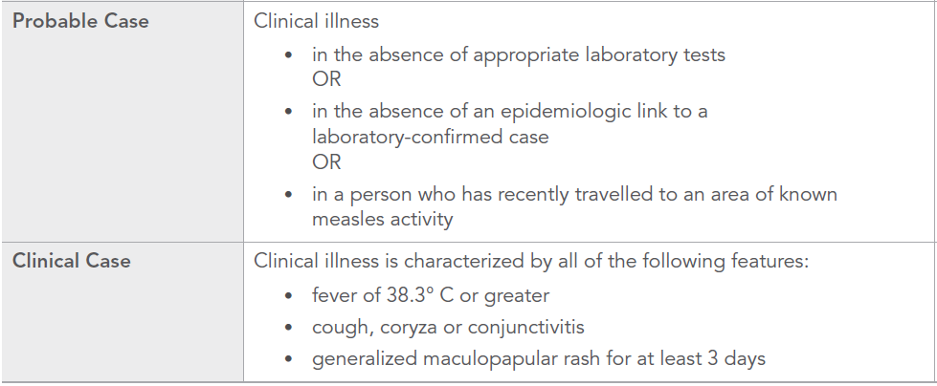
CCDR- September 2013

If measles is suspected:
- Advise the patient to wear a mask when they present to any healthcare setting, such as a laboratory, emergency department or clinic. Suspect patients should be placed on airborne precautions and evaluated promptly. Be sure to notify the receiving health care setting in advance of sending your patient for follow-up.

- Collect an NP swab (preferred) and/or urine for measles virus detection and blood for serologic testing (measles IgG and IgM). Refer to Measles protocol section 6.(p.4)
(NP swabs to be collected within 4 days of rash onset and urine can be collected until 7 days after rash onset) https://www.gov.mb.ca/health/publichealth/cdc/protocol/measles.pdf

3. Submit the Clinical Notification of Reportable Diseases or Conditions form, available at: www.gov.mb.ca/health/publichealth/cdc/protocol/form13.pdf

4. Clients should be advised to self- isolate (ie: avoid public places, public transit, gatherings or travel) until further direction by Public Health and/or health care provider.

5. Report info to CD Coordinator, if after hours call 204-788-8666 and ask for the Medical Officer of Health on call.

MHSAL Memo Feb 2015

MHSAL Immunization Eligibility Criteria

- Those born before 1970 are considered immune and do not require MMR vaccine.
- Non-immune Manitobans born between 1970 and 1984 are eligible for one (1) dose of MMR vaccine.
- Those born during or after 1985 are eligible for 2 doses of MMR vaccine.
- All children ≥ 12 months of age are eligible to receive 2 doses.
- Non-immune health care workers, regardless of age, are eligible for 2 doses of MMR vaccine.
- Non-immune students born before 1970 are eligible for 1 dose; students born in 1970 or later are eligible for 2 doses of MMR vaccine.

Calls from the Public : Symptomatic or Contact to a Confirmed Case

- Assess for symptoms. (see above)
- If symptomatic advise them to call their health care provider ahead of time alerting them that they may have measles (this is so MD can assess and proper precautions can be put In place)

- Clients should be advised to self- isolate (ie: avoid public places, public transit, gatherings or travel) until assessed further.

- If client meets the clinical criteria gather info using the Measles case form: http://www.wrha.mb.ca/extranet/publichealth/files/MeaslesCaseForm.pdf

- 6. Report info to CD Coordinator, if after hours call 204-788-8666 and ask for the Medical Officer of Health on call.

Information for the Client

What should I do if I think I have measles?
- If you have fever and a rash and think you may have measles, especially if you have been in contact with someone with measles or traveled to an area with a measles outbreak:
  - Have yourself examined by a health care professional. It is best to call ahead so that you can be seen quickly and without infecting other people. Measles can spread easily in places like waiting rooms and emergency rooms. The doctor or triage nurse can make sure that you are taken into a closed area for an examination and attend the clinic at a time when the waiting room is empty.
  - Bring your immunization record with you.
  - A physical examination, blood test, and throat swab or urine sample will be collected to make the diagnosis of measles.

How can I prevent spreading measles to others?
- The measles virus can be spread for up to 4 days after the rash appears. If you have measles you can help prevent spreading it to others by:
  - Staying at home for at least 4 days after the rash first appeared.
  - Washing your hands regularly.
  - Coughing or sneezing into a tissue or sleeve rather than your hands.
  - Not sharing food, drinks or cigarettes, or kissing others.

What is the home treatment?
After seeing a health care provider, the following home treatment tips may help you to be more comfortable while you rest and recover.
- Drink plenty of fluids such as water, juice and soup, especially if you have a fever.
- Get plenty of rest.

