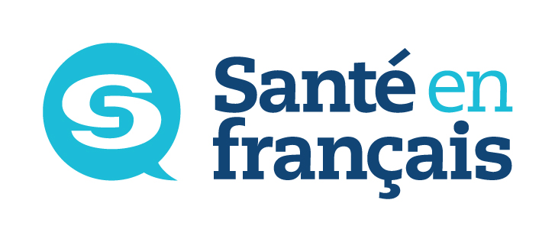
Le français en milieu de santé


*Register before
March 2nd and you could win back your $50 registration fee.

Registration Form – Program 1
SPRING 2018 (18P)
IMPORTANT NOTICE: Classes start the week of April 9th, 2018. Telehealth courses are offered at Saint-Boniface Hospital (SBH) or at Université de Saint-Boniface (USB). Students outside of the city can take classes by videoconference.
SEND COMPLETED APPLICATION FORM and REGISTRATION FEE TO:
French Language Services, A1153 – 409 Taché Ave. R2H 2A6
no later than Tuesday, March 6th, 2018.
$50 fee to be incurred by the student.
Cheques payable to Santé en français

Please fill out form and then print.
Santé en français offers these courses through
Université de Saint-Boniface’s Continuing Education Division.

Former Student – Last level completed:
New Student – Telephone number where we can reach you
for a placement interview:
Please check your answers:
Your position is: permanent term: if so, since when full-time part-time If PT, EFT
Your position is designated bilingual: yes no Your facility/program is designated bilingual yes no
You are in direct contact with: patients residents clients the public other

Level | Mondays  5 pm – 8 pm | Tuesdays  5 pm – 8 pm | Wednesdays  5 pm – 8 pm | Thursdays  5 pm – 8 pm
Level | April 9 to June 25  (no class on May 21) | April 10 to June 19 | April 11 to June 20 |  | April 12 to June 21
Beginner 1 (Telehealth) |  |  |  |  | (USB)
Beginner 2 (Telehealth) | (USB)
Beginner 3 (Telehealth) |  |  |  |  | (USB/SBH)
Beginner 4 (Telehealth) |  | (USB)
Intermediate 1 (Telehealth) |  |  | (USB)
Intermediate 2 (Telehealth) |  |  | (USB/SBH) |  | * Online courses require speakers, a microphone  and a webcam
Intermediate 3 | (*Online)
Intermediate 4 |  | (*Online)
Avancé (thème : Parlons-ens) |  |  | (*Online)
Perfectionnement  (after having completed three sessions at the Avancé level) |  |  | (USB) 6 to 9 p.m.  Communication orale :  D’un œil critique |  | (USB) 6 to 9 p.m.  Grammaire et communication : Vers un monde meilleur
Last name First name Home phone number Work phone number Cell phone number

Address City/Province Postal code

Personal e-mail address Work e-mail address
PLEASE CHECK YOUR E-MAIL REGULARLY AS COURSE CONFIRMATIONS WILL BE SENT BY E-MAIL.
Please be sure to check your “junk e-mail” folder as sometimes a new email address can be tracked as spam.
I HAVE READ AND UNDERSTAND THE INFORMATION SHEET PROVIDED BY SANTÉ EN FRANÇAIS
(signature)

Place of employment: Occupation:
Your signature: Date:
Signature of your workplace manager or contact person:
This personal information is being collected under the authority of The Université de Saint-Boniface Act. It will be used for the purposes of administering Le français en milieu de santé and Telehealth programs. It will not be used or disclosed for other purposes, unless permitted by the Freedom of Information and Protection of Privacy Act (FIPPA). If you have any questions about the collection of your personal information contact the FIPPA/PHIA Coordinator’s Office (204-237-1818, extension 398), Service des archives de l’Université de Saint-Boniface, 200 De la Cathédrale Avenue, Winnipeg, MB R2H 0H7.



French Language Training (FMS)
SPRING 2018

INFORMATION SHEET

The objective of the program is to develop employees’ linguistic abilities and to encourage them to apply for and work in a designated bilingual position in order to ensure quality services in French in Manitoba.
CRITERIA
To be eligible for French-language training for Français en milieu de santé, employees must:
- Be employed in a designated position, facility, program or department;
- Be employed in a permanent position or employed in a term position for more than 1 year;
- Be employed in a position that has direct contact with patients, residents, clients or the general public;
- Be committed to actively participate in a minimum of 24 hours of the 33 hours required per session regarding French-language training in order to achieve bilingual status.

REGISTRATION
- French language courses are provided free of charge by SANTÉ EN FRANÇAIS;
- A non-refundable deposit of $50 is required from every registrant to cover administration and coordination fees;
- Cheques are payable to SANTÉ EN FRANÇAIS;
- A surcharge of $20 will be added to all NSF cheques.

PROCEDURE
- Eligible employees should fill out a registration form, sign the “information sheet” and submit it to their FLS coordinator or contact person along with their $50 cheque prior to the deadline;
- The coordinator or contact person will forward student registration forms, signed “information sheets” and deposit cheques to SANTÉ EN FRANÇAIS. Please do not forward these directly to the language training facility.
- The language training facility will contact learners by e-mail to confirm course particulars such as start date, time and location approximately one to weeks prior to course start date.
- In order to be eligible to win the draw offered to those who register early, SANTÉ EN FRANÇAIS needs to receive the registrations with payment before midnight on the cut-off date indicated on the form. Further details regarding the draw can be found on the Official Rules document available from SANTÉ EN FRANÇAIS.

ACCESSIBILITY
- This document available in alternate formats upon request.
- Please let us know if you require an accessible classroom or other accommodations to remove barriers to participation.

CONSENT
By registering for this course, I consent to Santé en français and Université de Saint-Boniface sharing information about my enrolment status, my presence in class, and my final results with my employer.
For students participating via Telehealth or Adobe Connect:
I authorize the Coordinator to give my information (phone number and e-mail) to the Telehealth representative in order to plan the technical logistics regarding the course.

Signature: ____________________________________ Date: _________________________________

Important contacts:

REGISTRATION INFO COURSE COORDINATION
(Deadlines – Santé en français) (Missed class, content, questions & concerns)
Renée Beaudry Kristopher Noseworthy, Université de St-Boniface
(204) 235-3903 (204) 237-1818, ext. 495

SANTÉ EN FRANÇAIS reserves the right to accept or reject French-language training requests.
All decisions are final.

