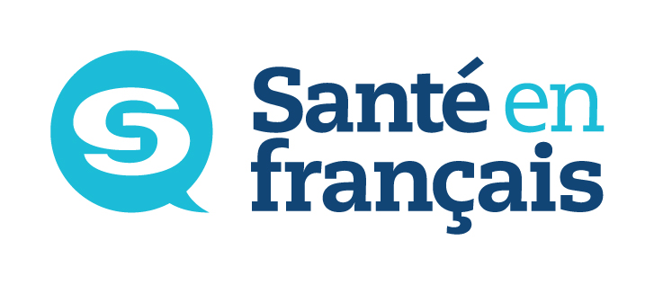

Le français en milieu de santé

*Register before
March 11th and you could win back your $50 registration fee.

Registration Form
SPRING 2016 (16P)
IMPORTANT NOTICE: Classes start the week of April 11th, 2016. Telehealth courses are offered at Saint-Boniface Hospital (SBH) or at Université de Saint-Boniface (USB). Students outside of the city can take classes by videoconference.
SEND COMPLETED FORM TO:
French Language Services, A1153 – 409 Taché Ave. R2H 2A6
no later than Monday, March 21, 2016.
$50 fee to be incurred by the student.
Cheques payable to Santé en français

Please fill out form and then print.
Santé en français offers these courses through
Université de Saint-Boniface’s Continuing Education Division.

Former Student – Last level completed:
New Student – Telephone number where we can reach you
for a placement interview:
Please check your answers:
Your position is: permanent term: if so, since when full-time part-time If PT, EFT
Your position is designated bilingual: yes no
You are in direct contact with: patients residents clients the public other
By registering for this course, I consent to the Division de l’éducation permanente’s sharing information with WRHA French Language Services about my enrolment status, my presence in class and my final results.

Level | Mondays  5 pm - 8:15 pm | Tuesdays  5 pm – 8 pm | Wednesdays  5 pm – 8 pm | Thursdays  5 pm – 8 pm
Level | April 11 to June 20  (no class on May 23) | April 12 to June 21 | April 13 to June 22 | April 14 to June 23
Beginner 1 (Telehealth) |  |  |  | (USB)
Beginner 2 (Telehealth) |  |  |  | (SBH)
Beginner 3 (Telehealth) | (USB)
Beginner 4 (Telehealth) |  | (USB)
Intermediate 1 (Telehealth) |  |  | (SBH)
Intermediate 2 (Telehealth) |  | (USB)
Intermediate 3 (Telehealth) | (SBH)
Intermediate 4 | (SBH)
Avancé (Teleheath)  (theme :Parlons-en) |  |  | (USB)
Perfectionnement  (after having completed three sessions at the Avancé level) |  | (USB)  Communication orale :  D’un œil critique | (USB)  Vers un monde meilleur
Last name First name Home phone number Work phone number Cell phone number

Address City/Province Postal code

Personal e-mail address Work e-mail address
PLEASE CHECK YOUR EMAIL REGULARLY AS COURSE CONFIRMATIONS WILL BE SENT BY E-MAIL.
Please be sure to check your “junk email” folder as sometimes a new email address can be tracked as spam.
If you do not use e-mail, the course will be confirmed by telephone.
Place of employment: Occupation:
Your signature: Date:
Signature of your workplace manager or contact person:
This personal information is being collected under the authority of The Université de Saint-Boniface Act. It will be used for the purposes of administering Le français en milieu de santé and Telehealth programs. It will not be used or disclosed for other purposes, unless permitted by the Freedom of Information and Protection of Privacy Act (FIPPA). If you have any questions about the collection of your personal information contact the FIPPA/PHIA Coordinator’s Office (204-237-1818, extension 398), Service des archives de l’Université de Saint-Boniface, 200 De la Cathédrale Avenue, Winnipeg, MB R2H 0H7.

